Grip strength, mating success, and immune and energy costs in US adults: a registered report

C. B. Smith and E. H. Hagen

2023-07-14

EHB Registered Report

### 1.1 Sexual dimorphism in modern humans:

The mechanisms that have shaped human sexual dimorphism and whether they have primarily operated on male or female traits remain debated. Sexual dimorphism refers to sex differences in morphological and behavioral traits, excluding reproductive organs (Plavcan, 2001). Unlike most animals, mammalian sexual size dimorphism tends to be male biased (Andersson, 1994). In humans, sexual size dimorphism is observable as early as the first trimester in utero where male embryos are larger than female embryos (Bukowski et al., 2007). Body composition dimorphism is evident through childhood such that, adjusted for height, males have higher lean body mass and females have higher fat mass (Kirchengast, 2010). At puberty, sexual dimorphism in size and body composition significantly increases such that in adults, adjusting for a 7-8% dimorphism for height, men have 12-25% higher body mass (Lassek & Gaulin, 2022), which is slightly greater than body mass dimorphism in gibbons, and slightly less than chimpanzees (Plavcan, 2012; Smith & Jungers, 1997). Men also have larger and stronger bones (Wells, 2007). Other traits that are sexually dimorphic in humans include digit ratio, voice pitch, facial features, body and facial hair growth, and canine length.

While humans are only moderately dimorphic in terms of overall body mass, this is not the case for fat and muscle allocation, which are highly dimorphic (Puts, 2010) due to women’s copious storage of fat and male investment in muscle mass. Men have between 30% and 42% more fat-free mass (Lassek & Gaulin, 2022), 61% more overall muscle mass, and 78% more muscle mass in the upper arms. This concentrated muscle dimorphism in the arms and back translates to greater upper body strength in men than women. Studies of sex differences in strength show that men are stronger on average than women on all tests of muscle strength, but especially for tests of upper-body muscle strength, where female upper-body strength is 50-60% of male upper-body strength while lower-body strength is 60-70% of male values, and trunk strength is 60% of male values (Nuzzo, 2023). Muscle mass alone does not explain the sex difference in strength, as strength assessments are often greater in males than females even when pair-matched on muscle thickness (Kataoka et al., 2023), and likewise men have greater strength-to-body mass ratios than women (Nuzzo, 2023).

There is no evidence for a sex difference in the ability of the nervous system to drive the muscle (voluntary action) but instead differences in strength lie in muscle characteristics including mass, size, and fiber type. Men have both more absolute muscle mass and greater mass proportional to body size, and these muscles have higher volume and cross-sectional area size. These differences are greatest in the upper body. Finally, a greater proportion of male to female muscle is occupied by type II muscle fibers, which create greater force than type I (Nuzzo, 2023).

### 1.2 Sexual dimorphism hypotheses

Darwin defined sexual selection as selection that acts, not to fit individuals to their environment, but instead as to confer advantage over others in competition for mates (Darwin, 1871). Modern definitions distinguish pre- and post-copulatory competition (Andersson and Simmons, 2006). A trait is likely to have been shaped by sexual selection when it is sexually dimorphic, develops at sexual maturity, and affects mating success, either through attracting mates or winning access to mates and fertilizations through contests, or both (Andersson, 1994). Two hypotheses for the evolution of human sexual size dimorphism and body composition dimorphism dominate the literature: 1) intrasexual selection through male contests and 2) intersexual selection through female mate choice. Both assert that men with more masculine traits had higher biological fitness over evolutionary history: intrasexual selection if more formidable men were able to physically outcompete other men for access to mates, and intersexual selection if females preferentially mated with men who displayed masculine traits. The male contest and the female choice hypotheses concur that sexual size and strength dimorphism are proximately (that is, developmentally) caused by sex differences in androgen hormones in the uterine environment and during differentiation at puberty. They differ, however, in the ultimate (functional) explanations for these differences, as discussed below.

#### 1.2.1 Male contest competition

The intrasexual selection hypothesis emphasizes evidence that female mate choice was limited in the ancestral past (Puts, 2010), and that instead male fitness was determined by physical contests with other males for access to mates. Under these circumstances more physically formidable males (i.e., those having the ability to inflict costs on competitors) had higher reproductive success (Puts, 2016, Hill et al., 2017; Plavcan, 2012). Therefore, human males have been sexually selected to be formidable resulting in the male bias in morphological traits like bone density, height, weight, muscle mass, and strength, as well as behavioral traits such as aggression (Archer, 2009). Particular emphasis is placed on sexual dimorphism in the upper-body due to the important role upper-body strength plays in both armed and unarmed fighting ability (Sell, et al., 2012) and where sex differences in strength and muscularity are greatest as discussed above.

In extant nonhuman primate species, sexual dimorphism in body weight and canine size are strongly associated with the degree of intrasexual competition, a relationship which, if used to infer the behavior of extinct australopithecines, suggests a high degree of intrasexual competition in ancestral species (Plavcan & van Schaik, 1997). Evidence of sexual size dimorphism in Homo is less certain, but in general shows reduced size dimorphism compared to early species (Plavcan, 2012).

#### 1.2.2 Female choice for masculine traits

In contrast to the intrasexual selection hypothesis, others argue that sexual dimorphism in humans is largely the result of female choice, not for more formidable or competitive mates, but for high quality males. The immunocompetence handicap hypothesis relies on evidence that testosterone is immunosuppressive, and therefore only males with highly competent immune systems can afford to pay the costs of high levels of testosterone required to develop masculine secondary sexual traits (Folstad & Karter, 1992). Therefore, androgen-dependent traits could be costly signals of good genetic quality, in which case females could increase their long-term fitness by preferentially mating with males displaying these traits thus conferring heritable immunity to their offspring and securing investment from a healthy partner (Folstad & Karter, 1992). Similar arguments have been proposed which argue that masculine traits could be more general cues of quality and condition other than immunocompetence, or ability to bear other costs (Kokko et al., 2003).

In humans, the immunocompetence hypothesis has primarily been leveraged to explain male facial masculinity and voice pitch but it and more general cost models have also been argued to explain apparent female preference for muscular male body types (Frederick & Haselton, 2007).

A few problems arise for this hypothesis. First, evidence that testosterone is actually immunosuppressive is mixed (Nowak et al., 2018). Likewise, masculine trait expression is not consistently related to retrospective or prospective health (Boothroyd et al., 2013). Secondly, it is unclear to what extent women are attracted to testosterone-dependent traits, for instance facial masculinity. Although testosterone is associated with mating success, it does not seem to be through the mechanism of female choice for testosterone-derived face or body features since testosterone does not predict female rated masculinity or attractiveness (Peters et al., 2008).

Females might also choose males who could provide more resources, which in ancestral hunter-gatherer populations might have been physically stronger men. It could also have been the case that mate choice was heavily influenced by parents, in which case parental preferences would have been important (see Hill et al. 2017 for a brief review of alternative hypotheses for sexual strength dimorphism).

More generally, multiple mechanisms of sexual selection could have played a role in the evolution of human sexual dimorphism. Nevertheless, there is evidence that mating success due to formidability is mediated by male-rated dominance and not by female-rated attractiveness (Kordsmeyer et al., 2018; Hill et al., 2013).

### 1.3 Strength and reproductive success

In a meta-analysis, Lidborg et al (2022) found that while voice pitch, height, and testosterone levels were associated with mating success in low fertility populations, only muscularity was associated with actual reproductive success in high fertility populations. The literature on the relationship between grip strength and mating and reproductive success is disproportionately reported for men (Gallup & Fink, 2018). Of the four studies which have tested the association between grip strength and sexual behavior, only two included both women and men (Gallup et al., 2007; Varella et al., 2014) and the other two only men (Shoup and Gallup, 2008; Sneade and Furnham, 2016). In all four, hand grip strength was positively related to mating success (including number of sex partners) for men, but there was either no relationship or a negative relationship for women. These four studies were in convenience samples.

There have been very few tests of the hypotheses that some female traits, such as breast size and waist-hip ratio (WHR), have evolved by sexual selection. In a meta-analysis, Lidborg and Boothroyd (2023) found weak evidence that more feminine digit ratios predicted higher fertility, insufficient evidence for voice pitch, and none regarding facial femininity, breast size or waist-hip ratio (WHR). At present there is mixed evidence that strength is related to reproductive success in women (Lidborg & Boothroyd, 2023). One study among the Himba showed that women with higher strength/muscularity had more living children and grandchildren (Atkinson et al., 2012), while a similar study among the Hadza showed no relationship between strength and reproductive outcomes (Smith et al., 2017). The dearth of research on female traits and reproductive outcomes leaves us unable to draw any firm conclusions about their selection pressures over time.

Previous research has shown that physical formidability in males (operationalized as fat free mass and limb muscle volume) predicts numbers of total and past-year self-reported sex partners, but that it also involves costs such as increased daily energy intake and decreased immune function (operationalized as C-reactive protein and white blood cell count) (Lassek & Gaulin, 2009), consistent with a tradeoff in mating success, immunity and energy costs. However, these relationships were not tested in women, for whom both selection hypotheses predict no association.

### 1.4 Experimental aims and hypotheses

The aim of this study is to replicate the costs and benefits of formidability reported by Lassek and Gaulin (2009) using similar nationally representative data, controlling for a wider range of possible confounds, and precisely prespecifying the statistical models in a registered report format. It also aims to investigate if these costs and benefits are also experienced by women.

In a large, nationally representative US sample, we predict that formidability will be significantly positively associated with mating success, with a significant interaction with sex such that strength will be a stronger predictor of male than female mating success. We also predict that there will be a negative association between male formidabillity and immune function, but little or no association for females. Finally, we predict that formidability will be positively associated with dietary energy intake for both males and females.

## 2. Pilot study

In order to refine our hypotheses and statistical models for our confirmatory study, which will use data we have not yet observed, we first conducted a pilot study whose results we report here.

### 2.1 Methods

To assess the relationship between formidability and mating benefits, and immune and energy costs, we used data from the Centers for Disease Control (CDC) National Health and Nutrition Examination Survey (NHANES). NHANES utilizes a complex, multi-stage sampling strategy in order to collect data representative of the civilian, non-institutionalized U.S. population. NHANES combines interview, examination, and laboratory data to assess health status and identify health risks for adults and children in the United States. Data collection occurs in new cycles every two years.

The pilot study uses the 2011-2012 dataset, whereas the 2013-2014 dataset has been held out for confirmatory analysis pending in principle acceptance of this registered report. Grip strength, our key predictor variable, was only collected in these years. We include data from US adults between the ages of 18 and 60, the years when grip strength is the most stable (Hogrel, 2015). For each model, participants will be included if they have complete data for each predictor and outcome variable.

#### 2.1.2 Key predictor variables:

Our main predictor variable is formidability, which Lassek and Gaulin operationalized as fat-free mass and limb muscle volume. Since those variables were not available in our data, we operationalized formidability as combined grip strength (kg), the sum of the highest of three readings taken on each hand using a dynamometer. All regression models also included sex (male/female), age in years, and partnered status (not included in models where partnered status was the outcome variable). The interaction between sex and strength was crucial for our models since we want to test if the effect of strength on mating and immune outcomes is different for women than for men. Likewise, we also interacted age and partnered status with sex. We interacted age with sex since menopause occurs within the age range of our participants. For models of past year number of sexual partners we included an interaction between partnered status and grip strength since being currently partnered would plausibly impact mating behavior in the past year regardless of strength. Continuous-valued predictor variables were centered and standardized by 2 standard deviations which approximately matches the variation in binary variables like sex, thus making the regression coefficients more comparable (Gelman, 2008).

#### 2.1.1 Outcome variables:

In industrialized populations like the U.S., widespread access to contraceptives uncouples reproductive success from sexual behavior. Measures of mating success, including number of sexual partners and age at first sexual intercourse, are used as proxies as they are assumed to have been strongly correlated with reproductive success under ancestral conditions (Pérusse, 1993). Our main outcome was mating success, which we operationalized in three ways following Lassek and Gaulin (2009): 1) Total sexual partners was a count based on responses to the question: “In your lifetime, with how many men/women have you had any kind of sex?” 2) Total sexual partners in past year, from the question: “In the past 12 months, with how many men/women have you had any kind of sex?” Because of the way these questions are framed, (e.g. female participants were asked about their male partners and vice versa) these variables represent heterosexual partners (however, it is not necessarily the case that all of the participants included in these models identified as heterosexual). 3) Age at first sexual intercourse reported from: “How old were you when you had sex for the first time?” The sexual behavior questionnaire was self-administered on a computer in a private room at the examination center, using the Audio Computer Assisted Self Interview system, which allows participants to hear questions through headphones as well as read them on screen. Only respondents who could self-report were asked these questions.

Unlike Lassek and Gaulin (2009), we also operationalized mating success in a fourth outcome measure as partnered status, as a proxy for longterm mating strategy since number of partners emphasizes success through short term mating strategies. Partnered status included participants who reported either being married or living with a partner whereas unpartnered included participants who reported being single, widowed, divorced, or separated.

Our second outcome measure was immune investment, which we operationalized as white blood cell count (1000 cells/ µL). In the original paper, Lassek and Gaulin (2009) also used C-reactive protein (CRP) as an outcome variable, but CRP was not measured in the 2011-2014 data collection years and so is not included here.

Finally, to assess costs of greater strength, we investigated the relationship between strength and dietary energy intake. Participants reported all food and beverages they consumed in the 24 hour period prior to their interview. This interview was repeated for a different 24 hour period 3-10 days later to obtain dietary recalls for two separate days. These data were then used to estimate energy intake in the form of kilocalories (kcal) calculated by matching reported foods to the USDA’s Food and Nutrient Database for Dietary Studies. For the outcome measure in this model we used the average number of calories per day calculated for each participant across their two recall days.

### Models:

We attempted to replicate the regression models in Lassek and Gaulin as closely as possible. There were some unavoidable differences, however. First, our study aimed to investigate the role of sex; thus we include sex as a main effect as well as in interactions with key predictor variables. Second, some variables included in Lassek and Gaulin were not available in our data. Third, we included additional control variables as noted below. Finally, we treated our pilot study as an exploratory study in which we fit numerous models not reported here. The models we report in the pilot study and which we will test exactly in the confirmatory study represent those that we consider to best test the hypotheses in Lassek and Gaulin (2009) based on the theories we have described above and given our constraints.

#### Control models:

Our modelling strategy takes inspiration from Lassek and Gaulin (2009). However, Lassek and Gaulin (2009) utilized stepwise regression to automatically eliminate candidate predictors from their models which has since been found to overfit data and therefore estimated coefficients fail to replicate in future samples (Smith, 2018). Instead, we will fit generalized linear regression models (GLMs) with prespecified treatment and control variables chosen based on theoretical considerations and our exploratory analyses. Control variables included a much wider range of theoretically motivated potential confounds than used by Lassek and Gaulin (2009), organized into themes. We specified five models for each mating success outcome measure in order to determine if the effect of grip strength on those outcomes was due to confounds with socioeconomic, health, hormone, or physical activity variables that have been associated with strength and sexual behavior.

#### Anthropometric control model

We first derived a simple model based on that reported in Table 2 in Lassek and Gaulin (2009) for each outcome measure (total number of partners, past year number of partners, and age at first intercourse) predicted by age, sex, grip strength, and partnered status. This model also includes an anthropometric control, body mass index (BMI), calculated as kg/m^2, since body size could impact either strength or mating outcomes. We interacted age, strength, and BMI with sex to assess differences in these predictors for men and women.

#### Socioeconomic control model

The socioeconomic control model included education and race as categorical variables, since there is evidence that race is related to variation in both strength (Johnson & Wilson, 2019) and sexual behavior (Fenton et al., 2005). Likewise, there is also variation in sexual behavior by education (Chandra et al., 2013), likewise there is variation in physical activity by education (He & Baker, 2005).

#### Health control model

An umbrella review found the grip strength is a useful indicator of general health status, early all-cause mortality, cardiovascular mortality, and disability (Soysal et al., 2021). Furthermore, health status is associated with higher likelihood of sexual activity, frequency of sexual activity, and reported quality of sex in men and women (Lindau & Gavrilova, 2010). Another study of men aged 45-59 found that lower sexual activity was associated with increased mortality (Smith et al., 1997). The health model, therefore, included a number of variables related to health. White blood cell count (1000 cells/ µL) and hemoglobin (g/dL) were included to control for acute infection. Depression, which is negatively related to strength (Smith et al., 2022), was measured using the Patient Health Questionnaire-9 (PHQ-9; Kroenke et al., 2001), a validated nine-item screening instrument. Each item represents a symptom of depression, and for each one participants were asked to consider how frequently they had been bothered by that symptom over the past two weeks, rated on a scale from 0 (not at all) to 3 (nearly everyday). These ratings were summed to produce a depression score ranging from 0-27. Chronic illness was included using Chronic Disease Score (0-6) a count of chronic diseases participants reported having been diagnosed with including diabetes, cancer, stroke, arthritis, heart disease and respiratory disease. A point was added for each disease a participant reported being diagnosed with, regardless of any impairment due to the disease. We then controlled for impairment resulting from chronic illness (Disease Impairment Score; 0-5) calculated from a different NHANES question, which asked participants to list up to five health conditions that specifically cause them to have difficulties with physical activities. We also controlled for physical disability and using the item “special equipment” which referred to participants’ report that they needed special equipment to walk. Finally the ‘perceived abnormal weight’ variable was coded as true or false depending on whether a participant reported that they perceived their weight to be abnormal.

#### Hormone control model

There is evidence that testosterone is associated with higher numbers of partners, but mixed evidence that it is related to sexual desire (van Anders, 2013). Likewise, evidence of a relationship between circulating testosterone and handgrip strength is also mixed (Nowak-Kornicka et al., 2020). The hormone control model included serum total testosterone (ng/dL). Since male mean testosterone is an order of magnitude higher than the female mean, testosterone was highly confounded with sex. We therefore computed a sex-specific testosterone value as follows: for each sex we centered testosterone at the sex-specific mean and divided by two times the sex-specific standard deviation. This differed from other centered and standardized variables which we centered and standardized across all male and female values.

#### Physical activity control model

Physical activity is related to sexual behavior and function in adults (Morris et al., 2022). Therefore, the physical activity control model included four dichotomous variables of vigorous and moderate work and recreational activity coded as 1 if participants reported that their work and/or recreation caused large increases in heart rate or breathing for at least 10 minutes continuously (vigorous work and/or rec), or small increases in breathing or heart rate for 10 minutes continuously (moderate work and/or rec), and zero if they reported their work and/or recreation did not.

#### Costs of strength

Following Lassek and Gaulin (2009) we also developed models of native immune function (operationalized as white blood cell count) and dietary energy intake (operationalized as average calories per day). For each outcome we developed a model as similar as possible to those reported in Lassek and Gaulin (2009), except that we always include sex and its interaction with other predictors where we have theoretical reasons to expect sex differences in the effect of the predictor on the outcome. We then also specified an alternative model for each outcome with additional control variables that could confound strength and energy or immune investment. These models were based in part on exploratory analyses of multiple models not reported here.

#### Native Immune Function

Following the significant predictors reported in Lassek and Gaulin (2009, Table 4), we first specified a replication model with age, sex, strength, and BMI. We also included an age:sex interaction because we expected that immune investment over the lifespan might differ between males and females due to menopause in women. Finally, we included a strength:sex interaction to test the hypothesis that the immune costs of strength differ by sex.

Based on exploratory analysis we developed an expanded control model of WBCC that included a few additional controls. First, we controlled for sex-specific testosterone and an interaction of sex and sex-specific testosterone since testosterone possibly has immunosuppressive effects, which may differ by sex. We also controlled for three variables related to energy availability that could impact immune investment. First, food security status for adults in the participant’s household was assessed using 10 items from the U.S. Food Security Survey Module. The resulting value can range from 1-4, where 1 represents full food security and 4 represents very low food security. Second, the total metabolic equivalent (total MET) was calculated based on participants’ responses to questions about the minutes they spent walking or bicycling, engaging in vigorous and moderate work, and vigorous and moderate recreation per day, using MET scores provided by NHANES. Finally we included dietary energy intake (average calories per day as discussed above).

#### Dietary Energy Intake

Based on Lassek and Gaulin (2009, Table 3) we developed a replication model of dietary energy intake (average calories per day) and included age, sex, strength, BMI, and total MET. We did not include interactions with sex in this model because we do not anticipate sex differences in the effects of any predictor variable, nor did we see any in exploratory analyses.

We then developed an expanded control model that also controlled for WBCC and food insecurity in addition to the variables in the model above, since either could influence energy intake and strength.

### Analysis

All analyses were completed in R version 4.0.2 (2020-06-22), using the survey package (version 4.1-1; Lumley, 2021) in order to incorporate the survey sampling weights and to preserve the representative structure of the sample. For models of lifetime and past year numbers of partners we modeled the outcomes using a poisson distribution, since these variables are count data. Models of age at first sexual intercourse and white blood cell count utilized a normal distribution. Analyses include adults ages 18-60 because this is the period when the majority of reproduction takes place and because these are the years when grip strength is the most stable.

### 2.2 Pilot Study Results

#### 2.2.1 Descriptive statistics

Table ?? shows weighted means and standard deviations of all variables for men and women. Mean age was 38 years for this sample. Sexual dimorphism is given as a ratio of male mean:female mean. Larger male size dimorphism is reflected in an 8% higher value for height and a 16% higher value for weight; females, however, had a 1% higher BMI than males on average. There is a much larger degree of dimorphism in combined grip strength (57%). Hemoglobin is 14% higher in males than females while white blood cell count is 3% higher in women.

## ℹ Column headers among stacked tables differ. Headers from the first table are  
## used. Use `quiet = TRUE` to supress this message.

## Table printed with `knitr::kable()`, not {gt}. Learn why at  
## https://www.danieldsjoberg.com/gtsummary/articles/rmarkdown.html  
## To suppress this message, include `message = FALSE` in the code chunk header.

(#tab:sexual dimorphism)**Sex differences for participants ages 18-60 using population weights**

**Variable**

**N**

**Mean (SD)**

**N**

**Mean (SD)**

**Ratio**

*d*

**Age at first sex (years)**

1,639

17.15 (3.90)

1,599

17.45 (3.46)

0.98

-0.08

**Lifetime number of sexual partners**

1,735

22.17 (85.56)

1,666

8.79 (21.30)

2.52

0.21

**Past year number of sexual partners**

1,692

1.50 (2.88)

1,624

1.10 (2.05)

1.36

0.16

**Combined Grip Strength (kg)**

1,828

93.04 (17.11)

1,779

59.20 (10.46)

1.57

2.39

**Age (Years)**

2,077

38.93 (12.72)

2,115

39.19 (12.31)

0.99

-0.02

**Body mass index (kg/m^2)**

1,981

28.43 (6.06)

2,012

28.82 (7.59)

0.99

-0.06

**Height (cm)**

1,983

176.26 (7.60)

2,015

162.84 (7.21)

1.08

1.81

**Weight (kg)**

1,982

88.45 (20.30)

2,013

76.42 (20.67)

1.16

0.59

**White blood cell count (1000 cells/µL)**

1,892

6.94 (2.03)

1,946

7.19 (2.09)

0.97

-0.12

**Hemoglobin (g/dL)**

1,892

15.12 (1.09)

1,946

13.28 (1.16)

1.14

1.64

**Testosterone (ng/dL)**

1,828

410.86 (170.54)

1,867

25.73 (23.25)

15.97

3.17

**Chronic Disease Score (0-6)**

1,909

0.40 (0.66)

1,958

0.54 (0.82)

0.74

-0.19

**Disease Impairment Score (0-5)**

2,077

0.21 (0.69)

2,114

0.27 (0.83)

0.78

-0.09

**Depression Score (0-27)**

1,782

2.76 (4.13)

1,710

3.51 (4.57)

0.79

-0.17

**Dietary energy intake (kcals)**

1,588

2,547.65 (847.80)

1,689

1,855.66 (619.82)

0.93

**Food Insecurity Rating (1-4)**

2,070

1.56 (0.98)

2,106

1.58 (0.98)

0.99

-0.02

**Total MET**

2,067

88.11 (114.56)

2,111

42.25 (69.44)

2.09

0.48

**Partnered**

1,920

1,116 (60%)

1,966

1,094 (61%)

**Education**

1

2,077

137 (4.9%)

2,115

122 (4.1%)

2

2,077

339 (13%)

2,115

294 (10%)

3

2,077

486 (23%)

2,115

403 (18%)

4

2,077

627 (32%)

2,115

710 (35%)

5

2,077

488 (28%)

2,115

586 (33%)

**Race and Ethnicity**

MexicanAmerican

2,077

251 (9.9%)

2,115

226 (9.0%)

OtherHispanic

2,077

194 (7.1%)

2,115

235 (7.5%)

NonHispanicWhite

2,077

714 (64%)

2,115

675 (61%)

NonHispanicBlack

2,077

525 (11%)

2,115

582 (14%)

NonHispanicAsian

2,077

318 (5.2%)

2,115

337 (5.8%)

OtherRace

2,077

75 (2.9%)

2,115

60 (2.6%)

**Perceived abnormal weight**

2,069

994 (51%)

2,111

1,309 (63%)

**Special equipment needed to walk**

1,920

87 (3.0%)

1,967

113 (4.6%)

**Work involves vigorous activity**

2,077

544 (30%)

2,115

208 (11%)

**Work involves moderate activity**

2,077

799 (42%)

2,115

598 (32%)

**Recreation involves vigorous activity**

2,077

778 (37%)

2,115

466 (25%)

**Recreation involves moderate activity**

2,077

932 (48%)

2,115

943 (50%)

#### 2.2.2 Anthropometric models of mating success

In the anthropometric control model (Figure 1), strength was significantly associated with higher numbers of lifetime and past year sex partners and an earlier age at first sex, and the interaction with sex was not significant.

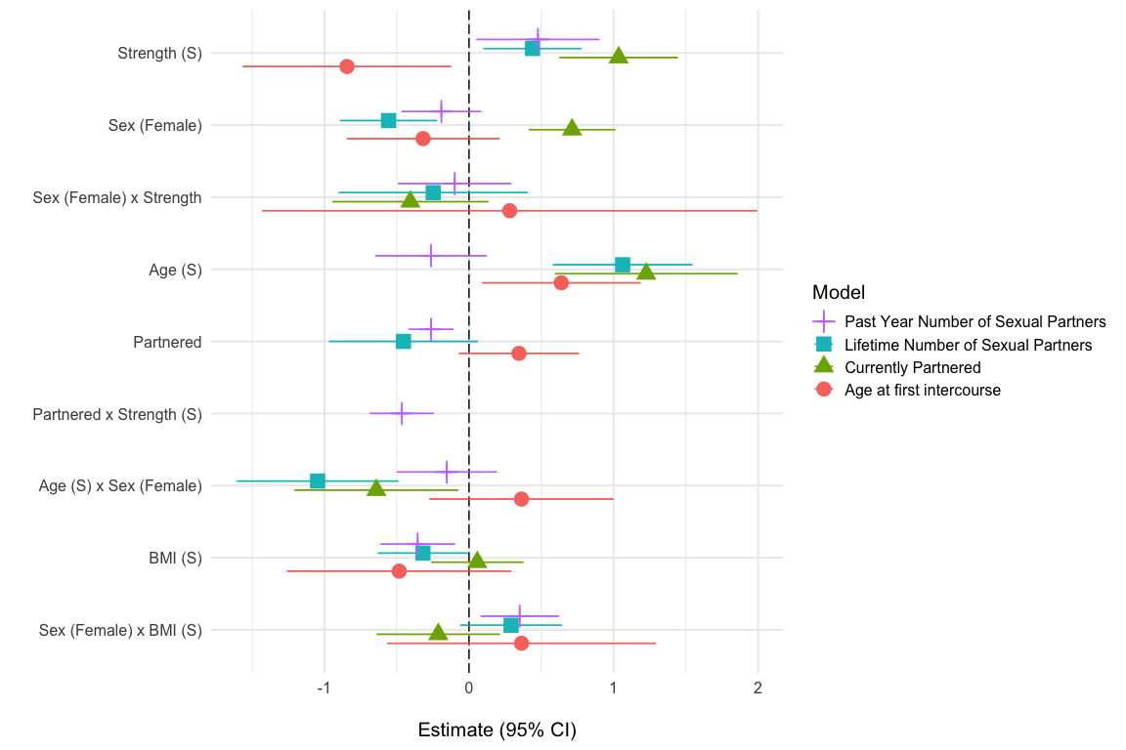

Figure 1: Anthropometric Models: Coefficent plot from generalized linear models (Pilot). Variables labelled (S) have been centered at the mean and standarized by 2 SD.

#### 2.2.3 Models of mating success with socioeconomic, health, hormone, and physical activity controls

We then used generalized linear regression to evaluate the impact of a host of other potential confounds on these results. For lifetime number of sex partners, strength remained a significant positive predictor when controlling for socioeconomic, physical activity, health, and hormone variables, with no interaction with sex. This was also the case for past year number of sex partners, except in the case of the hormone control model. Strength predicted an earlier age at first sex for all models except the socioeconomic. There was no significant interaction between sex and strength in any model.

We also modeled partnered status. While strength was a significant predictor of currently being partnered in each model, a significant sex:strength interaction emerged in the physical activity and hormonal control models such that the strength effect was reduced for women. Coefficients are shown in Figure 2.

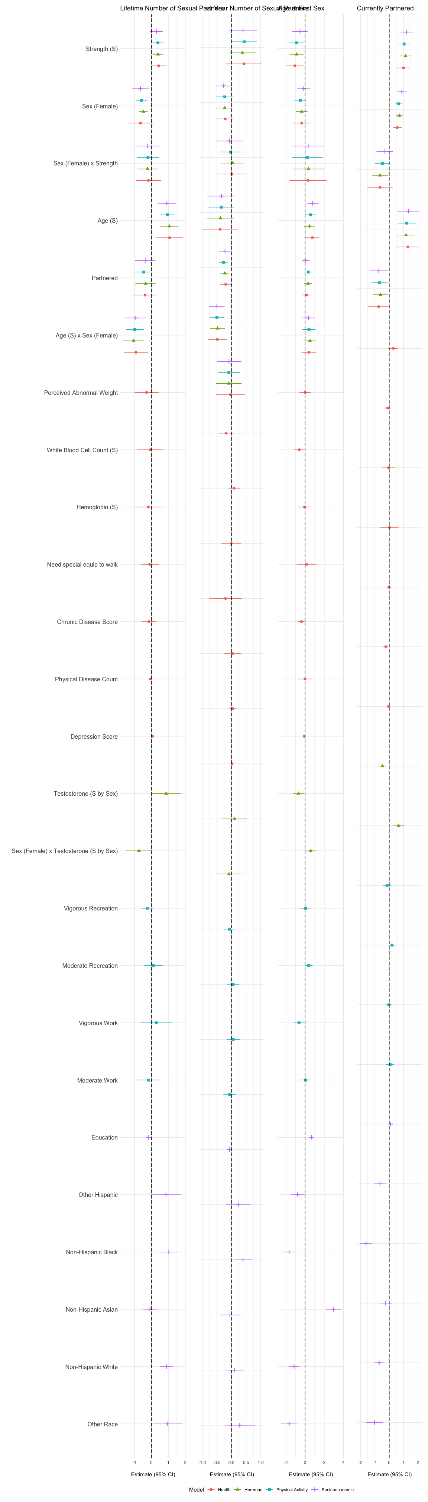

Figure 2: Additional Control Models: Coefficent plots for predictors of mating success from generalized linear models. Variables labelled (S) have been centered at the mean and standarized by 2 SD.

#### 2.2.4 Immune costs of strength

Previous research found that higher musculature was associated with decreased investment in native immunity. We developed two models of immune investment in white blood cell count (Figure 3). In the replication model, strength was a significant negative predictor of WBCC for both men and women (there was no significant interaction of sex and strength) controlling for age and BMI. In the expanded control model, this pattern remained even with additional controls (see Table ).

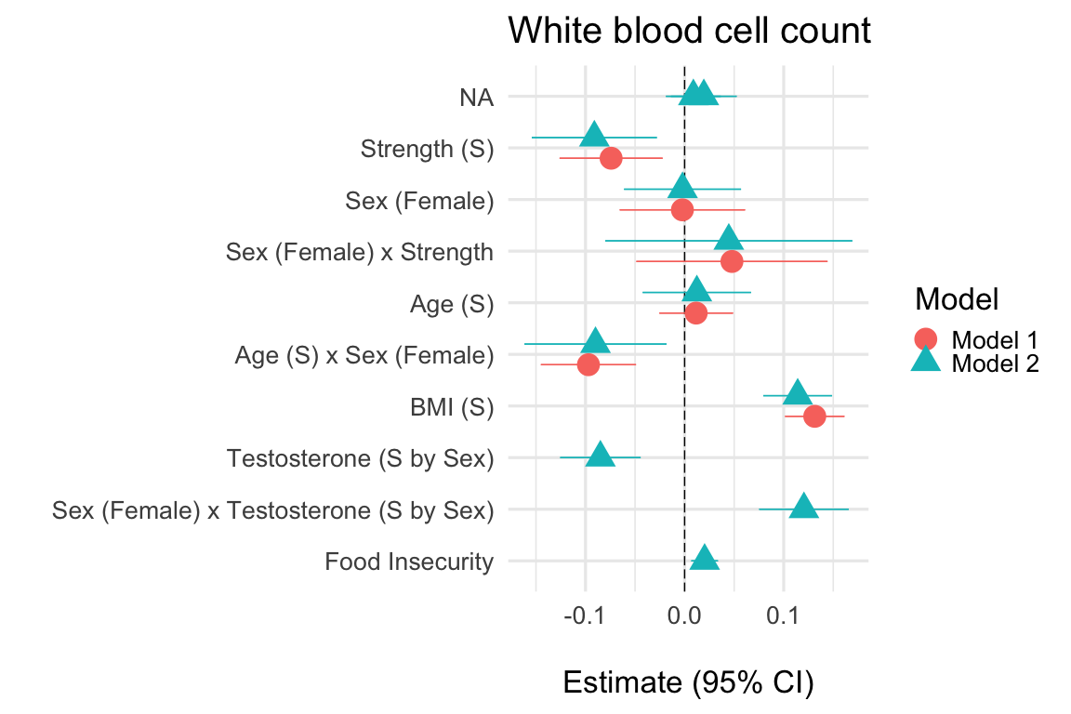

Figure 3: Coefficient plot of predictors of immune investment (WBCC) from generalized linear models. Variables labelled (S) have been centered at the mean and standarized by 2 SD.

#### 2.2.4 Model of energy intake

Finally, we tested whether strength was related to increased energy intake (Figure 4). We found that strength was a significant, positive predictor of energy intake controlling for sex. In the expanded control model we found the same pattern while controlling for additional variables.

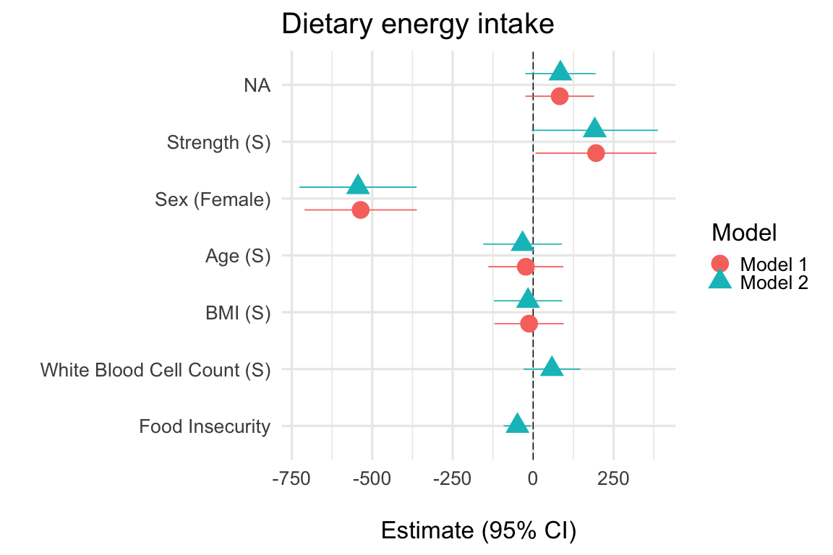

Figure 4: Coefficient plot of predictors of dietary energy intake (kcals) from generalized linear models. Variables labelled (S) have been centered at the mean and standarized by 2 SD.

### 2.3 Pilot Results Discussion

In this pilot study using grip strength as a proxy, we replicated findings from Lassek and Gaulin (2009) that muscularity is associated with increased mating success, as well as with immune and energy costs, even after controlling for a wider range of potential confounds including socioeconomic, health, hormone, and physical activity variables. The only exception was that strength was not a positive predictor of past year partners in the hormone control model; the coefficient, however, remained similar in magnitude to the significant strength coefficients in other models of past year partners. In addition, strength was a positive predictor of partnered status, an additional index of mating success.

We found that the negative effect of strength on age at first sex may be due to a confound with ethnicity. Specifically, Asian Americans have markedly lower grip strength compared to Mexican Americans and later age at first sex. For this reason, we do not predict an effect of strength on age at first sex controlling for ethnicity.

We extended these findings to include women in order to test the hypothesis that sexual dimorphism in strength is due to sexual selection for formidability. At the outset of our study we predicted that strength would be a strong predictor of mating success for men and a significantly weaker predictor for women. Contrary to predictions, in our pilot study we found no significant interaction between strength and sex for lifetime number of partners or past year number of partners. This calls into question the sexual selection hypothesis for sexual dimorphism in upper body strength, because our results confirm that strength has immune and energy costs that would be offset by the benefits of multiple mates for men but less plausibly for women. We did, however, find evidence that strength was a significantly stronger predictor of partnered status for men than for women. In humans biological fitness depends critically on extensive investment in offspring which typically takes place in long-term partnerships. We therefore propose that the sexual selection hypothesis for the sexual dimorphism in physical formidability clearly applies to long-term partnerships (proxied by our partnered variable), where strength was a stronger predictor for men than women. Partner numbers are arguably better proxies for short term mating success.

The lack of a sex difference in the significant positive effect of strength on short term mating success is puzzling. Because men have greater strength than women their partner numbers are higher. Still, women with higher grip strength report more partners than women with lower grip strength even after controlling for a host of potential confounds. It could be that there was selection for more formidable men to prefer more partner variety, and stronger women have a similar preference as a byproduct of selection on men. It could be that there is assortative mating on strength; thus if stronger men are motivated to switch partners more frequently their (stronger) mates would also necessarily have more mates. It may be that stronger women require less male investment and so instead benefit from greater partner numbers through e.g. genetic bet-hedging, forging relationships with multiple males, ability to conduct a more extensive search for high quality long term mate, or through avoiding costly long term partnerships. It might also be the case that there are some sex-specific confounds that we failed to control for. Finally, greater partner numbers might indicate mating failures rather than mating successes for males or females, although why strength would be associated with mating failures is not clear.

## 3. Confirmatory Analysis [not yet conducted]

We indicate our predictions for the results of the confirmatory tests, specifically, our predictions for significant coefficients of strength and of the interaction between sex and strength, in Table X. We indicate for each outcome whether we predict a significant positive, negative, or no effect of these variables across our control models. If the effect of strength on the outcome variable is not significant in any single model, especially if the size of the coefficient is markedly reduced, then we will consider that evidence against the sexual selection hypothesis.

### 3.1 Method

Our methods and models will remain identical to those reported in the pilot study, using unobserved data from the 2013-2014 NHANES collection cycle.

#### References